**ESD Tests on  
Protektive Pak  
Versus   
Coated ESD Boxes**

This purpose of these tests and report is to determine the effective shielding of Coated ESD boxes versus Protektive Pak boxes. Also this report will determine the level of resistance in the Protektive Pak box’s buried carbon layer.

The boxes tested for this comparison were limited to the small size boxes approximately 2.5 X 7.8 X 10 inches. This means that the product when inserted into the box is approximately 1 inch from the outside of the box during any ESD event. These should be the worst case for “Air Gap” shielding comparison. Air Gap shielding is the reduction of the voltage and therefore the energy available for damage to a component by the air separation. In 3 D packages, all events are transformed from a contact/ conductive injection of energy to a radiated signal which has much less available energy.

The ESD Association’s Test Standard STM 11.31 was developed to test Static Shielding bags. It uses a 1000 volt HBM discharge on the top of the bag and senses the injected current inside the bag with a capacitive electrode. The current through a resistor develops a voltage which is captured on a high speed oscilloscope. The resulting waveform is used to calculate the energy a product would see inside. ESD S 541 sets the limit at 50 nano joules (nJ). Most bags test much less than this agreed to limit. In fact a very high shielding bag such as the conductive nickel outside bag will test less than 3 nJ by this test.

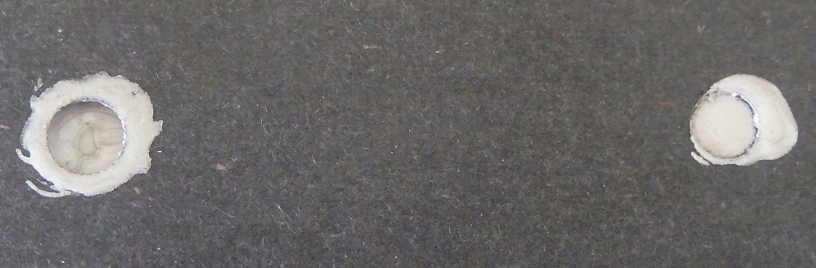

The main differences with the two box types, Protektive Pak and the Coated box, is the PROTEKTIVE PAK box has a dissipative outer layer and the Coated box has a conductive outer layer.

The coated box had surface resistances (per ESDA STM 11.11) in the range of 5 – 7 E3 Ohms. This is considered conductive.

The Protektive Pak box had surface resistances in the range of 1E6 Ohms to 1E8 Ohms. This is considered dissipative.

Both say they have a buried “shielding” layer. Both state that the buried shielding layer is 1E3 to 1E4 Ohms.

The Coated box with an outer layer also in this range cannot be verified to have a buried conductive layer. In fact there would be little advantage to a 1E 3 layer below a 1E3 layer.

The Protektive Pak box with a dissipative outer layer could be verified to have a buried conductive layer. This verification is shown below:

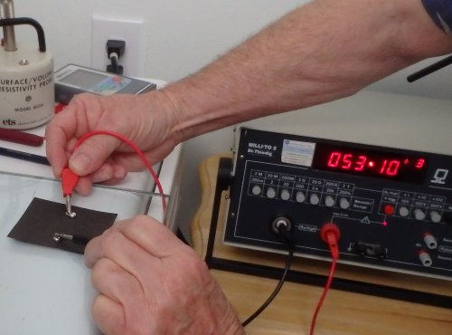

Mercury reading = 5.3E3 Ohms

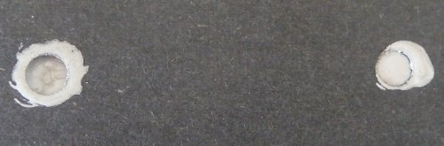

Silver Paint reading = 9.2E3 Ohms

Taking into account the contact area error of such measurements, the buried layer should be less than 1E4 Ohms/square

Note: a buried conductive layer for either box in the 1E3 Ohms range would provide some electrostatic shielding. However, neither box can provide significant electromagnetic shielding which requires a resistance of much less than 377 Ohms – the impedance of free space. The shielding provided by both boxes is “Air Gap” shielding for the electromagnetic radiated signals, plus shorting of the ESD event to ground by the outer layer of carbon loaded material plus the reduction of the energy of the discharge by limiting the conduction of the event to the material. The rf signal drops off with distance. The 1 inch distance from the outside of the box to the product provides this “air gap” shielding.

In any ESD event, the potential and capacitance of the part or person which causes the discharge combined with the resistance to ground at the point of discharge determines the energy of the discharge and therefore the energy of the injected signal to the component inside the package. When a package has a dissipative outside layer, the discharge energy will be much lower than a package which has a conductive outside layer.

The following pictures show a plasma created by a 10 kV power supply on both boxes. The plasma was used to show the relative energy of the discharges to a conductive package versus a dissipative package. In a single ESD event the relative levels would be the same. The plasma allows a continuous discharge so that a photo may be taken to show the difference.

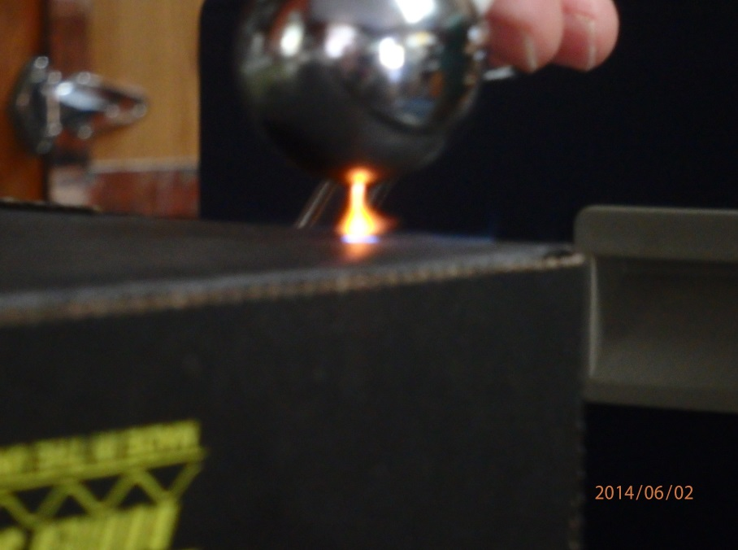

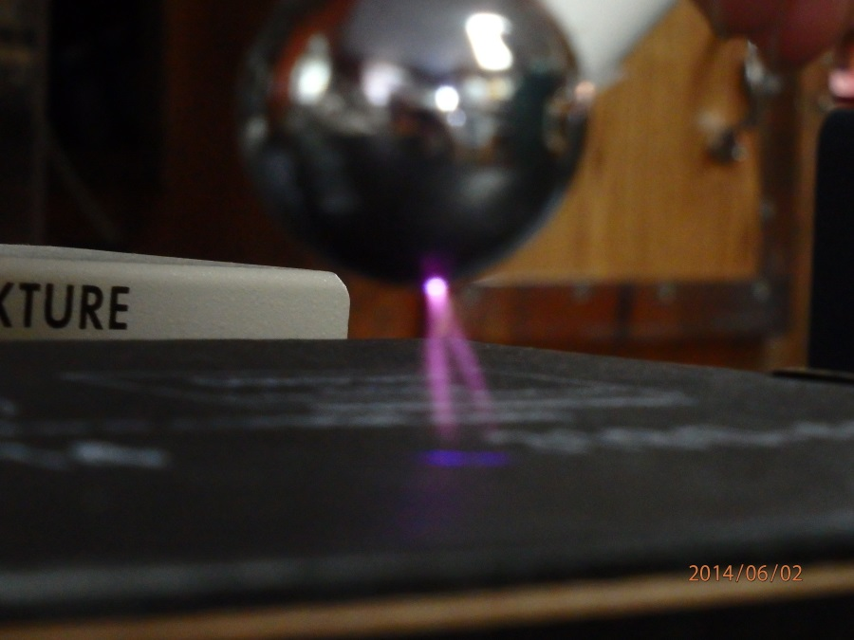

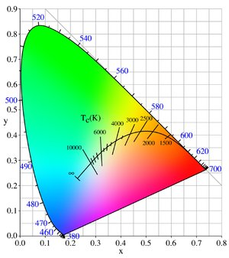

From the photos, and the above color versus temperature charts, it can be seen that the 10 kV d.c. plasma to the Coated box was much more energetic than the Protektive Pak box. The plasma to the Coated box was bluish in color and the Protektive Pak was yellow. This means the temperature of the plasma was greater than 10,000 degrees K for the Coated box and 2500 to 3000 for Protektive Pak. This is relative to the energy in the discharge to the box. This is due to the higher conductive layer of the Coated box versus the Protektive Pak box.

In the early days of ESD prevention, 3M sold metal out bags. These had a conductive metal layer on the outside of the bag. Many experts in the ESD field believed that this promoted too energetic a discharge versus a dissipative outside layer bag. Most bags today are “metal in” bags which mean the outside and inside layers are dissipative with a buried metal layer of aluminum in the lamination. The differences between the Protektive Pak box and the Coated box are very similar to this progression of shielding bags in the industry. The Coated box has a very conductive outside layer and the Protektive Pak box has a dissipative outside layer. Both state they have a buried shielding layer which is most likely a heavy carbon loaded layer instead of an aluminized layer as in bags. The aluminum layer in bags is necessary because the ESD event occurs at the outer side surface of a bag. Carbon loading in boxes is appropriate because there is an air gap between the product and the ESD event.

The following sets of graphs compare the energy levels inside the boxes and also in comparison to a very conductive outer layer nickel coated ESD bag. This test is the standard 1000 V HBM ESDA 11.31 test protocol. As can been seen, they all pass the ESDA S541 requirements of “less than 50 nJ” They all are very low. Most of the energy inside is from radiated fields. The conductive bag achieves this by a heavy nickel layer and the boxes achieve the same effect by a conductive layer and air gap shielding. The Protektive Pak box performs in most tests nearer the heavy conductive bag due to the outside layer having a dissipative resistance level. This disallows the HBM pulse from achieving its maximum energy for the discharge. The HBM model has a resistance in the path of the discharge limiting the energy of the discharge. A conductive surface adds little further reduction in this energy of discharge. A dissipative outside layer such as in the Protektive Pak box and most metal out ESD shielding bags, limits the HBM discharge energy further. One HBM model has a series resistor of 1500 Ohms. This is 1.5 E3 Ohms which is similar to the resistance of the outer layer of the coated box. This means the HBM model still has approximately E3 Ohms limiting to the energy. When a box has E6 – E8 Ohms, the energy is reduced significantly because the resistance to the discharge is 1000 – 100,000 times more dampened.



**Coated Box**



**Protektive Pak**



**Nickel Metal Outside Bag**

**(2 ¼ X 7 X 10 inch boxes)**

**Coated Box = 4.23 nJ  
  
Protektive Pak Box = 2.28 nJ**

**Nickel Bag = 2.97 nJ**

To make the difference more obvious, a 10 kV HBM discharge was presented to the top of each box with the electrode inside near the inside top of the box, not in the middle as would be the position of the product.

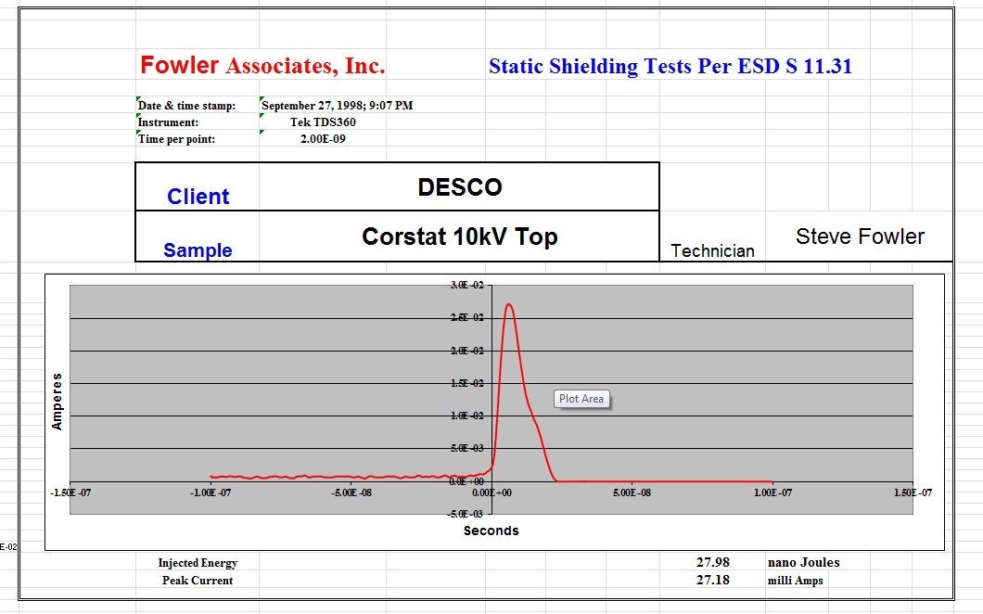

**Coated**

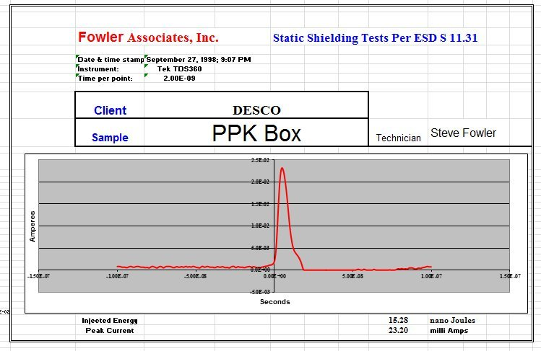

As can been seen even with 10 times the potential level of the discharge required by the ESDA STM 11.31, the boxes both pass the ESDA S541 spec of 50 nJ. Even with the electrode out of normal position at the top inside surface, the boxes both are reasonable for static shielding. This high level of HBM discharge shows the difference of the energy of the discharge due to a conductive surface versus a dissipative surface. The coated box had almost two times the energy allowed inside due to the level of energy in the original discharge.

To determine the performance of the boxes to a discharge to a product sitting on top of the box we, discharged directly to the electrode on top of the box. The energy of the discharge will be controlled by the conductivity (or lack of conductivity) of the box itself. This is a scenario where a customer uses the box as a work station platform. Most ESD experts would never allow a product to be set on a conductive surface after being handled as it was removed from a package. The following are the oscilloscope traces not the energy calculations. The relative height and width of the discharge make it clear that a dissipative box such as the Protektive Pak allows much less energy in such a discharge.

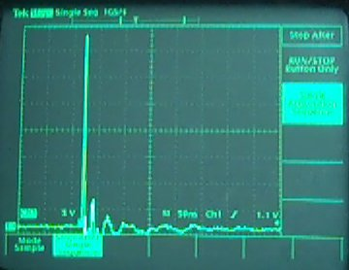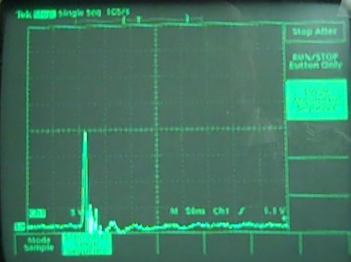

**Coated Box** ( same scale) **Protektive Pak Box**

**Conclusions**

1. The Protektive Pak box has a conductive buried layer in the order of E3 Ohms
2. The Protektive Pak box equals or exceeds the static shielding capabilities of the coated boxes
3. The Protektive Pak box has static shielding capabilities equal to a highly conductive metal out shielding bag.
4. The Protektive Pak box minimizes the levels of energy discharged to a product resting on top of the box due to the dissipative outside layer.



The data and conclusions of this report are based upon the information and samples supplied to Fowler Associates for the tests described herein. Product users should make his or her own tests to determine the suitability of the information and conclusions herein stated or implied for their intended use, and shall assume all risk and liability in connection therein.

Janice Fowler, CFO, Fowler Associates, Inc